ATTENDANCE RECORD
Date: 20th April 2012
To,
The Principal,
Shah and Anchor Kutchhi Engineering College,
Chembur,
Mumbai-88.
Subject: Confirmation of attendance.
Respected Sir,
This is to certify that the Final Year (B.E.) students of your college
Ms. Rishita. D. Vaghela. Ms. Jruvika. M. Bhimani. Ms. Neha. P. Jangale.
have duly attended the sessions on the day allotted to them during the period 07-1-2012 to 14-4-2012 for performing the project titled, Digital Watermarking of Videos.
Following is the detailed record of their attendance.
Attendance Record:
Date | Rishita. D. Vaghela | Jruvika. M. Bhimani | Neha. P. Jangale
07-01-2012 | Present | Present | Present
14/01/2012 | Present | Present | Present
09/02/2012 | Present | Present | Present
18/02/2012 | Present | Present | Present
25/02/2012 | Present | Present | Present
01/03/2012 | Present | Present | Present
08/03/2012 | Present | Present | Present
15/03/2012 | Present | Present | Present
22/03/2012 | Present | Present | Present
29/03/2012 | Present | Present | Present
07/04/2012 | Present | Present | Present
14/04/2012 | Present | Present | Present

Internal Guide
(Prof. Mrs. Swati Deshpande)
ACKNOWLEDGEMENTS

We wish to express our sincere gratitude to Prof. Mrs. Swati Deshpande, HOD of Information Technology department of Shah and Anchor Kutchhi Engineering College, Chembur, and also our project guide for providing us an opportunity to do our project on “Digital Watermarking of Videos” and for her able guidance and useful suggestions which helped us during project work.
We are thankful to our Principal Dr. B. K. LANDE and our college staff for the encouragement and support that they have extended.

TIME AND TASK MANAGEMENT PLAN

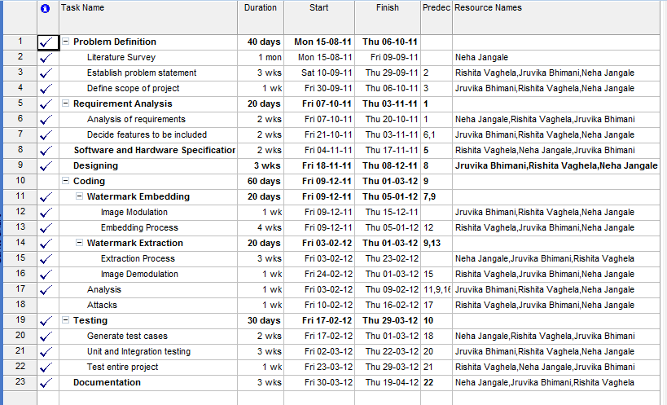

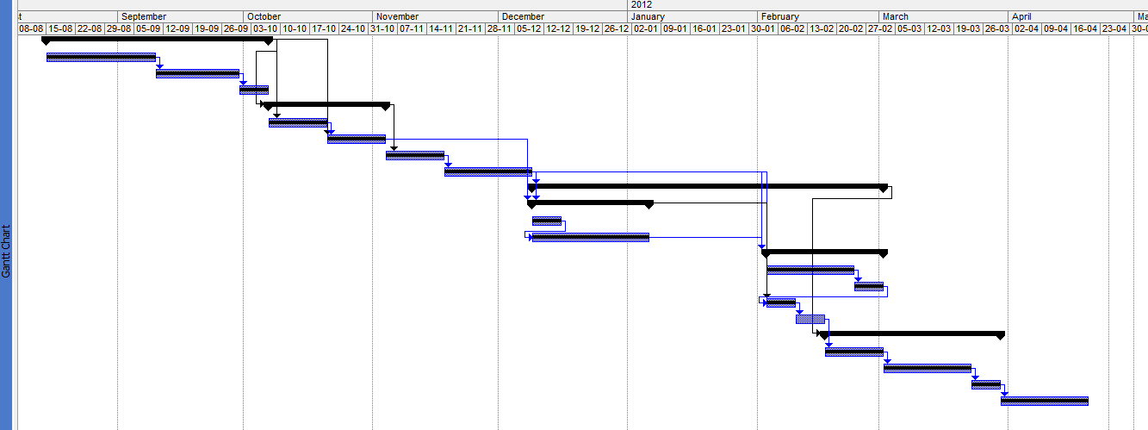
ABSTRACT

Digital watermarking relates to a technology known as Steganography, which literally means "Covered Writing". It is a technique designed to secure a message by hiding information into the original message. It is important for Digital watermarking to have digital data and multimedia, such as video, music, text, and image copyright protection because of network and multimedia techniques that easily copy. One of the significant problems in video watermarking is the Geometric Attacks. The proposed algorithm for digital watermark is robust against geometric attacks that do not significantly degrade the receiver’s perception of the video sequence. The watermarking technique is applied in spatial domain. The video watermarking has been performed on gray-scale videos using a binary image. In order to combine a watermark with a digital data, a video is required, a signature that contains the watermarking information, and an encoding algorithm to create a watermarked video. The encoder takes the signature, covers the document, and generates the watermarked video. Symmetric or public key or other parameters can also be added to extend the watermarking encoder. The watermark is extracted using a decoder function. In this case, the decoder loads the watermarked, normal or corrupted video, and extracts the hidden signature. Using non-blind watermarking techniques, the decoder loads an additional video, which is often the original video, to extract the watermarking information by correlation. The encoding-decoding algorithm proposed in this document consists of XORing methodology and is designed to be robust against geometric attacks. The experimental result show that embedded watermark is invisible and robust.
TABLE OF CONTENTS
Attendance Record i
Acknowledgement ii
Abstract iii
1. Introduction 1
1.1. Overview of Watermarking 1
1.2. Video Watermarking 2
1.3. Properties of Video Watermark 3
2. Literature Survey 4
3. Problem Statement 5
4. Requirement Analysis 6
4.1. Introduction 6
4.1.1. Purpose 6
4.1.2. Documentation Convention 6
4.1.3. Intended Audience 6
4.1.4. Additional Information 6
4.1.5. Contact Information 7
4.1.6. References 7
4.2. Overall Description 7
4.2.1. Product Perspective 7
4.2.2. Product Function 13
4.2.3. User Classes and Characteristics 13
4.2.4. Operating Environment 14
4.2.5. User Environment 14
4.2.6. Design and Implementation Constraints 14
4.2.7. Assumptions 14
4.3. External Interfaces Requirements 15
4.3.1. User Interfaces 15
4.3.2. Hardware Interfaces 15
4.3.3. Software Interfaces 15
4.4. Other Non-functional Requirements 15
4.4.1. Performance Requirements 15
4.4.2. Safety Requirements 16
4.4.3. Security Requirements 16
4.4.4. Software Quality Attributes 16
4.5. Other Requirements 17
4.5.1. Terminology/ Glossary/ Definitions List 17
5. Implementation Details 22
5.1. Module and Description 22
5.2. Snapshots 24
6. Testing 31
7. Result and Analysis 33
8. Conclusion and Future Scope 36
References 37
LIST OF FIGURES
1. Model of Watermarking Algorithm 8
2. Model of the Watermark 9
3. Block Procedure 10
4. Extraction of Watermark 12
5. System Block Diagram 19
6. DFD for Sender 20
7. DFD for Receiver 21
8. Original Video and Image GUI 24
9. Waitbar to indicate Conversion of Video to Frames 24
10. Passkey to Encrypt Watermark 24
11. Modulating Watermark Image 24
12. Modulated Watermark 24
13. Watermark Embedding into Frames 25
14. Location and File name to Save Watermarked Video 25
15. Converting Watermarked Frames to Video 25
16. Embedding Process Successful 25
17. Original Video 26
18. Watermarked Video 26
19. Original Video, Watermarked Video and Original Image GUI 27
20. Converting Original Video to Frames 27

21. Converting Modulated Video to Frames 27
22. Selecting Directory to Save Watermarked Video 27
23. Accepting Name for Watermarked Video 27
24. Passkey to Demodulate Watermark Image 28
25. Extracting Watermark from Video 28
26. Original Watermark Image 28
27. Extracted Watermark Image 28
28. Original and Watermarked Frames to Calculate PSNR, &
Original and Extracted Logo to Calculate NC 29
29. PSNR & NC value 29
30. GUI to Perform Cropping Attack 30
31. Original and Cropped Frame 30
32. Original and Extracted Watermark after Cropping 30

